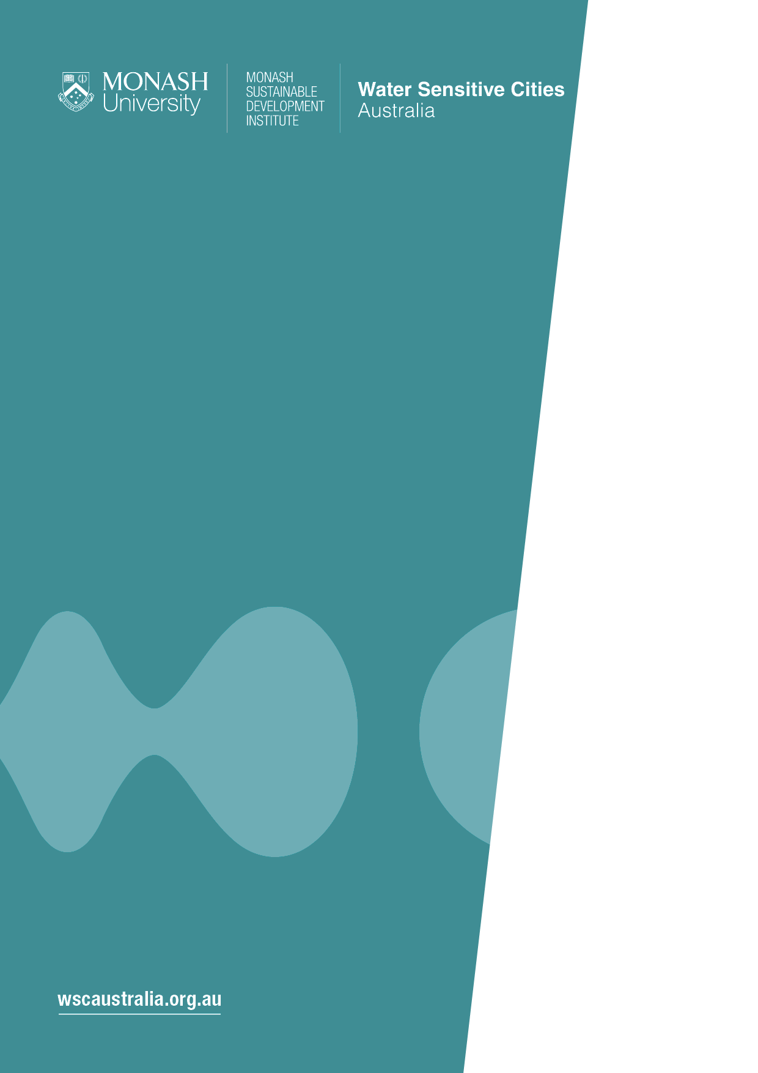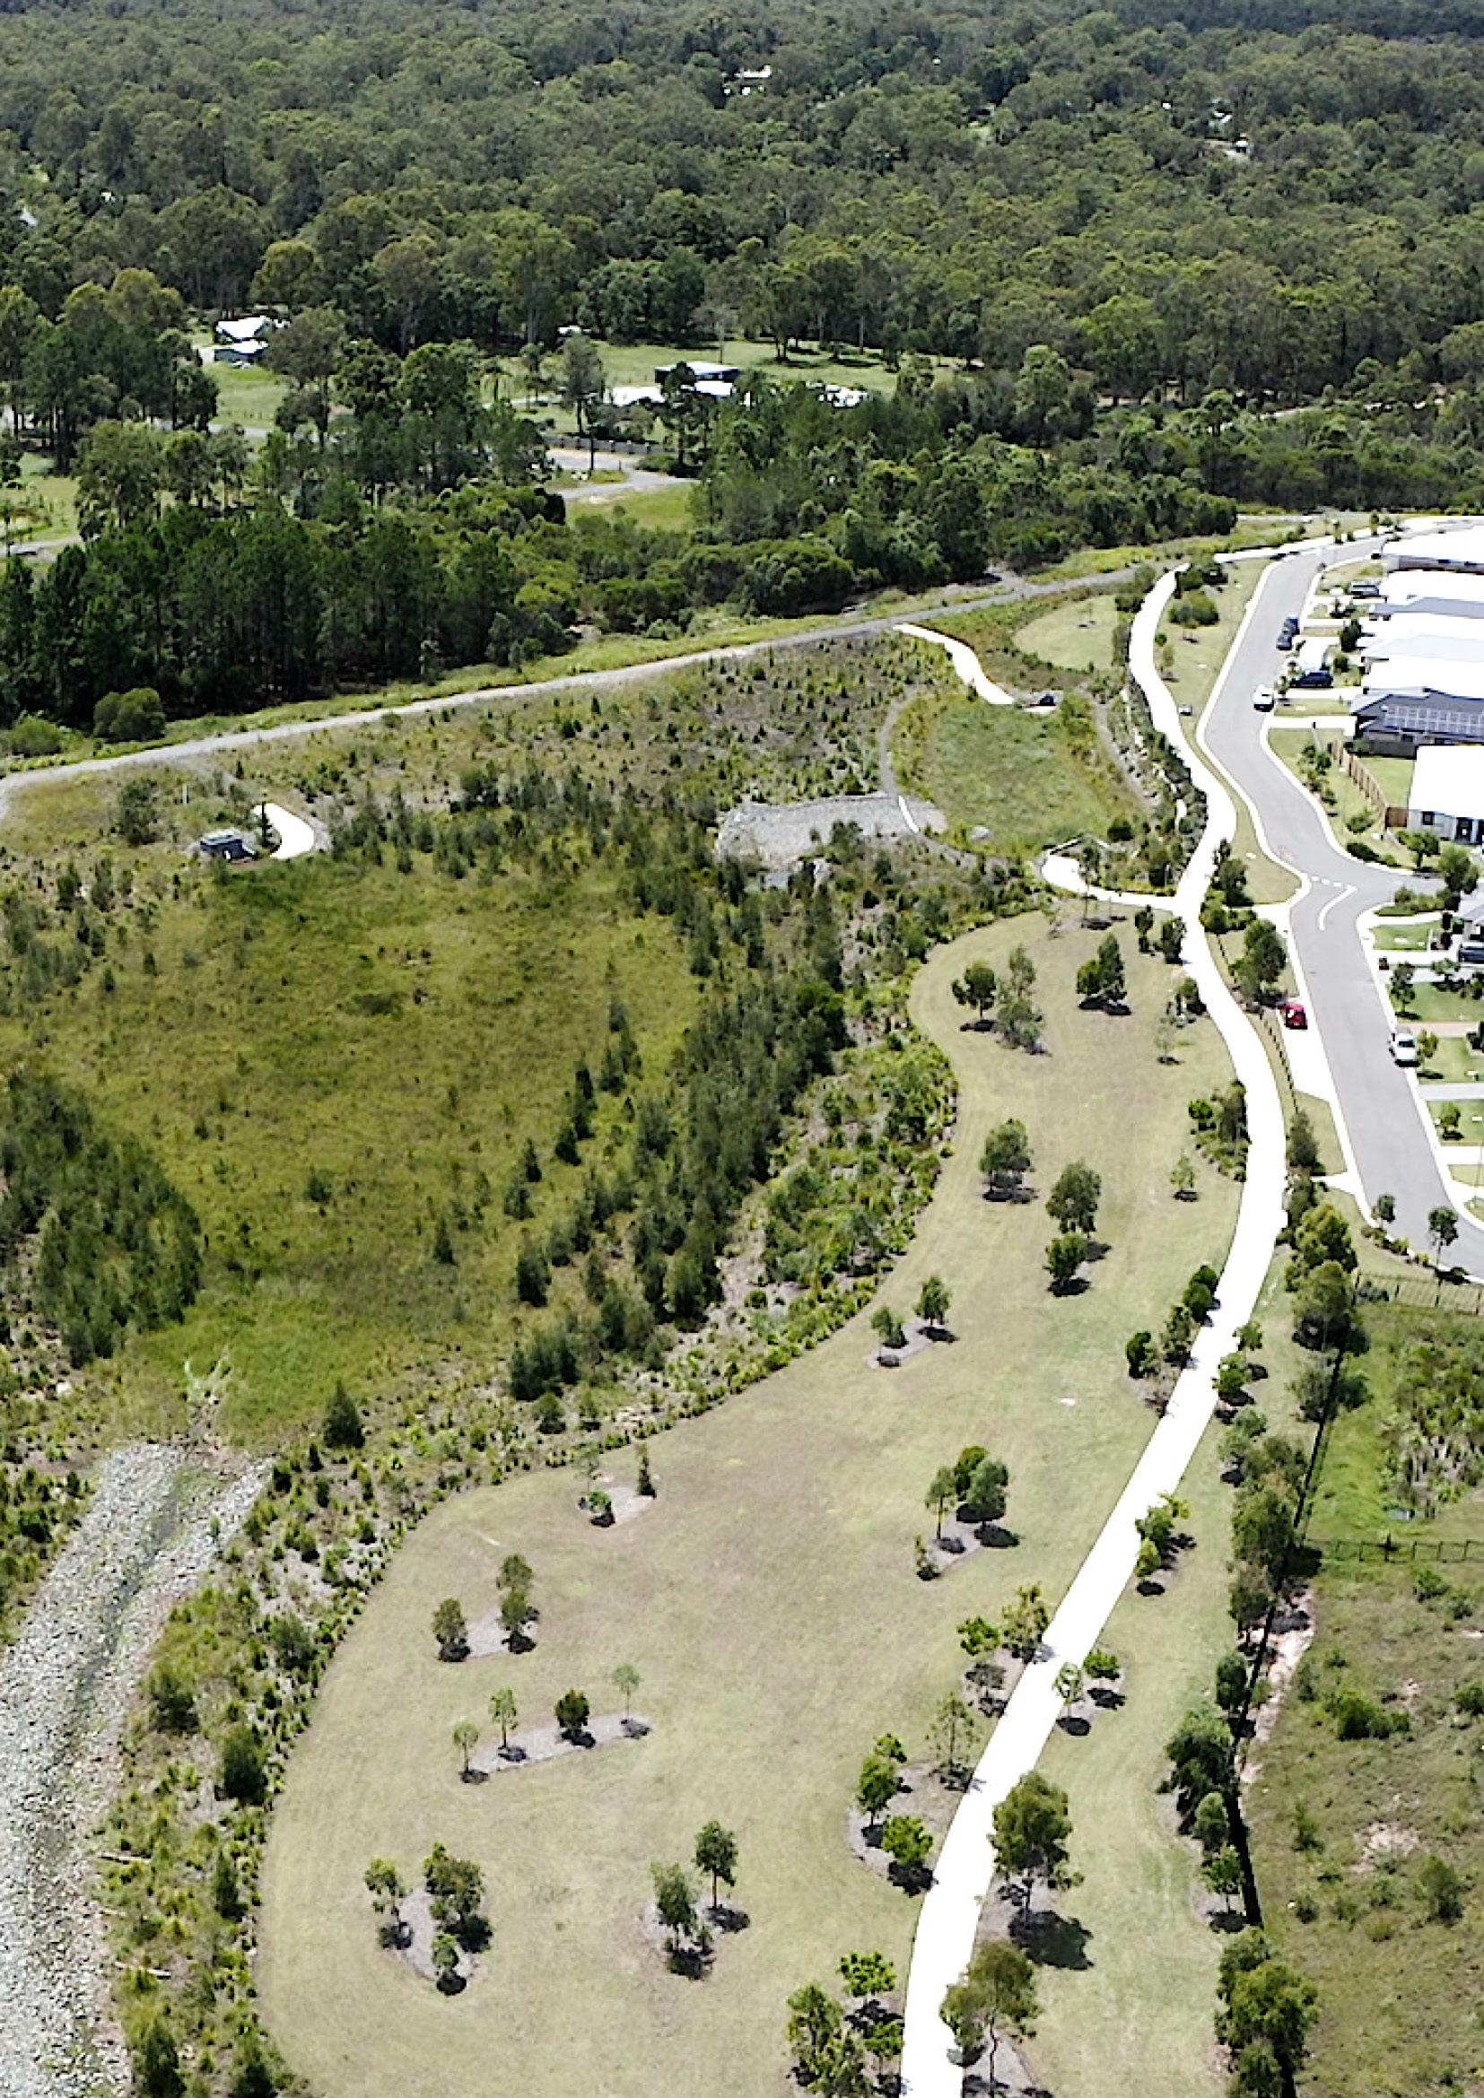­­

Transition strategy   
for Insert place name

Draft/Final report

Month year

**Document Title**  
Transition strategy for Insert place name

**Authors**  
Insert author names

© 2024 Water Sensitive Cities Australia

This work is copyright. Apart from any use permitted under the Copyright Act 1968, no part of it may be reproduced by any process without written permission from the publisher. Requests and inquiries concerning reproduction rights should be directed to the publisher.

**Publisher**

Water Sensitive Cities Australia  
8 Scenic Blvd, Clayton Campus  
Monash University  
Clayton, VIC 3800

**e.** info@wscaustralia.org.au  
**w.** www.wscaustralia.org.au

**Date of publication:** Insert month and year

**An appropriate citation for this document is:**

Authors (Year). Transition strategy for Place name.  
Melbourne, Australia: Water Sensitive Cities Australia, insert partner organisation details.

**Disclaimer**

Water Sensitive Cities Australia has endeavoured to ensure that all information in this publication is correct. It makes no warranty with regard to the accuracy of the information provided and will not be liable if the information is inaccurate, incomplete or out of date nor be liable for any direct or indirect damages arising from its use. The contents of this publication should not be used as a substitute for seeking independent professional advice.

Contents

Acknowledgements 4

Glossary 5

1. Introduction 6

1.1 About this project 6

2. The North East Region’s water story 9

2.1 About the region 9

2.2 Looking to the past 11

3. Looking ahead - A vision for the region 16

4. Assessing the region’s current IWM performance 18

5. Advancing the IWM transition 23

5.1 Assessing the North East’s IWM transition progress 24

5.2 13 strategies to embed IWM 26

6. Towards strategy implementation 34

7. Conclusion 35

8. References 36

Appendix 1. Urban Water Transitions Framework 37

Appendix 2 Benchmark results 42

Appendix 3 Representing the Strategic Direction Statement Vision as a future benchmark result 43

Appendix 4 Goal Area transition results 46

Acknowledgements

This Transition Strategy was funded by Insert name of funding body and was developed in collaboration with:

Insert stakeholder logos

Glossary

|  |  |
| --- | --- |
| **Integrated water management (IWM)** | A holistic and collaborative approach to the way we plan for and manage all elements of the water cycle. IWM considers how the delivery of water, wastewater and stormwater services can contribute to water security, public and environmental health, and urban amenity. It fundamentally shifts the way water, land use planning and urban development opportunities are understood and undertaken in Victoria. |
| **Narrative** | A well-articulated rationale and/or compelling case for a particular practice or action,  including a description of its ecological, economic and social benefits |
| **Transition** | A fundamental shift in cultures, structures and practices as society changes from one pattern of socio-technological development to another usually more sustainable pattern |
| **Transition Dynamics Framework** | A framework that conceptualises how system-wide changes in practice (e.g. the transition to water sensitive practices) unfold over time, based on the establishment of key enabling factors: individual and organisational champions, platforms for connecting, science and knowledge, projects and applications, and tools and instruments |
| **Urban form** | The physical characteristics that make up the built environment, including urban density and size, parcels and buildings, public spaces, ecological assets and key services such as transport and drainage |
| **Urban Water Transitions Framework** | A framework that conceptualises different forms of urban water servicing as a city responds to evolving drivers: Water Supply City, Sewered City, Drained City, Waterways City, Water Cycle City and Water Sensitive City |
| **Water sensitive city (WSC)** | A WSC provides water system services in a way that reflects an integrated approach to infrastructure, the built form, the environment, governance and community, to deliver outcomes that support the enduring sustainability, liveability, resilience and productivity for a place’s community and ecosystems. |
| **Water Sensitive Cities Index** | A tool to benchmark and diagnose the water sensitive performance of a place (from the municipal to metropolitan scale), based on 34 indicators organised by 7 goals: good water sensitive governance, community capital, equity of essential services, productivity and resource efficiency, ecosystem health, quality urban space and adaptive infrastructure |
| **Water sensitive urban design (WSUD)** | An approach to the planning, design and maintenance of urban landscapes that will deliver WSCs through protecting and enhancing natural water systems and integrating the management of the total water cycle |

1. Introduction

1.1 About this project

Insert organisation name was engaged to develop transition strategy for Insert place name. The project aimed to Insert project aims (e.g. guide XXX’s transition to a water sensitive city, guide XXX to accelerate the uptake of IWM).

For this project, a transition strategy process was applied to Insert place name. It involved facilitating stakeholder workshops and applying benchmarking and diagnostic tools to identify ways to Insert project aim (e.g. embed IWM). Insert participant roles (e.g. policy makers, water planners, urban planners, catchment managers, engineers) from Insert participant organisations participated in the project in Insert month(s) and year.

This report presents a framework for orienting and coordinating strategic action to Insert project aim (e.g. embed IWM). It is anticipated that this report can be used as a resource by Insert client organisation to guide future discussion and projects.

Alongside practical guidance for Insert place name’s water sector, the engagement process has strengthened relationships among stakeholders and built momentum and commitment to Insert project aim (e.g. embed IWM as a business-as-usual practice).

Description of project

Insert a description of the project including:

* description of place
* map of place (Figure 1)
* project drivers (e.g. new infrastructure development, response to climate change, community expectations).

Insert map

**Figure 1. Map of Insert place name/area/region**

What is a water sensitive city transition?

In Australia, the concept of a water sensitive city (WSC) is now widely used to represent an aspirational concept in which water has a central role in shaping a city or town. In a WSC, people are not disrupted by flooding, and can enjoy reliable water supplies, effective sanitation, healthy ecosystems, cool green landscapes, efficient use of resources and beautiful urban spaces that feature water and bring the community together.

A WSC incorporates innovative infrastructure, design and governance solutions. For example, water recycling at different scales through wastewater recovery and stormwater harvesting provides diverse water sources and improves the health of downstream rivers and creeks by reducing pollution and flow impacts. Water sensitive urban designs (WSUDs) integrate nature-based infrastructure into the landscape to provide hydraulic and water treatment functions, as well as amenity benefits such as an aesthetic environment and mitigation of urban heat island effects. Integrated and collaborative land use and water planning results in catchment-scale approaches to enhancing flood resilience and connecting areas of green and blue to create ecosystem and recreation corridors. Citizens are active in caring for water and the environment, and there is cohesion among the community as their sense of place and collective identity is nurtured through their connection with water.

However, a WSC approach often requires a significant departure from the conventional mode of water servicing and urban planning. The conventional approach typically manages water as separate streams for water supply, wastewater and stormwater through large-scale, centralised infrastructure; it also overlooks the opportunities to create blue and green infrastructure in urban areas. These conventional approaches have given us critical benefits such as safe and secure water, sewerage and drainage services, and this mode of servicing is still an important part of a WSC. However, we now recognise that adaptations are needed to address key social and environmental vulnerabilities that result from conventional approaches, such as degraded waterways, impacts of uncertain and extreme rainfall patterns, and growing community expectations for improved urban liveability.

The Urban Water Transitions Framework (Figure 2) depicts the evolution in water system servicing as these drivers unfold. Most cities in the world would appear somewhere on this continuum, however, a city’s journey from a Water Supply City through to the aspirational Water Sensitive City is not linear. Australian cities are typically somewhere between a Drained City and a Water Cycle City, with features across all 6 of the city–states.

Fully transitioning to a WSC requires changes in policy and practice as the water servicing system moves through the different city–states. This transition relies on commitment and alignment among many different people and organisations. Developing a shared perspective of how water is managed today, a compelling vision for the future and a framework to guide coherent strategic action is critical for establishing the understanding, motivation and capacity among stakeholders to drive their WSC transition.

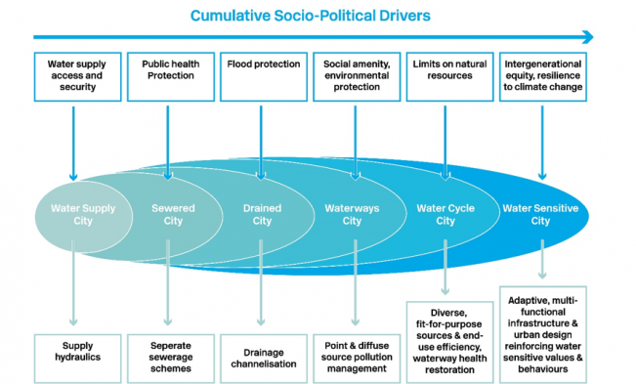

**Figure 2. Urban Water Transitions Framework (Brown, Keath & Wong, 2009)[1]**

1. Insert place name’s water story

2.1 About Insert place name

Insert a description of place name, e.g:

* state/country it is located in; metropolitan, regional or rural (including additional maps if relevant)
* approximate size and population, including growth forecasts
* water assets (e.g. rivers and waterways, catchments, environment, infrastructure assets (water storages, wastewater treatment plants, desalination plants etc.))
* land uses (e.g. urban, agricultural, public open space, national/state parks and reserves)
* stakeholders (e.g. local governments, state government, Traditional Owners, other land holders)
* current water management approaches/policies/practices.

2.2 Looking to the past

The history of water management in Insert place name is a tale of adaptation, innovation and evolving approaches to meet the diverse and often conflicting needs of people, agriculture and the environment. From Indigenous water management practices to the complex regulatory frameworks of the 21st century, Insert place name’s water management has undergone significant historical changes (Figure 3).

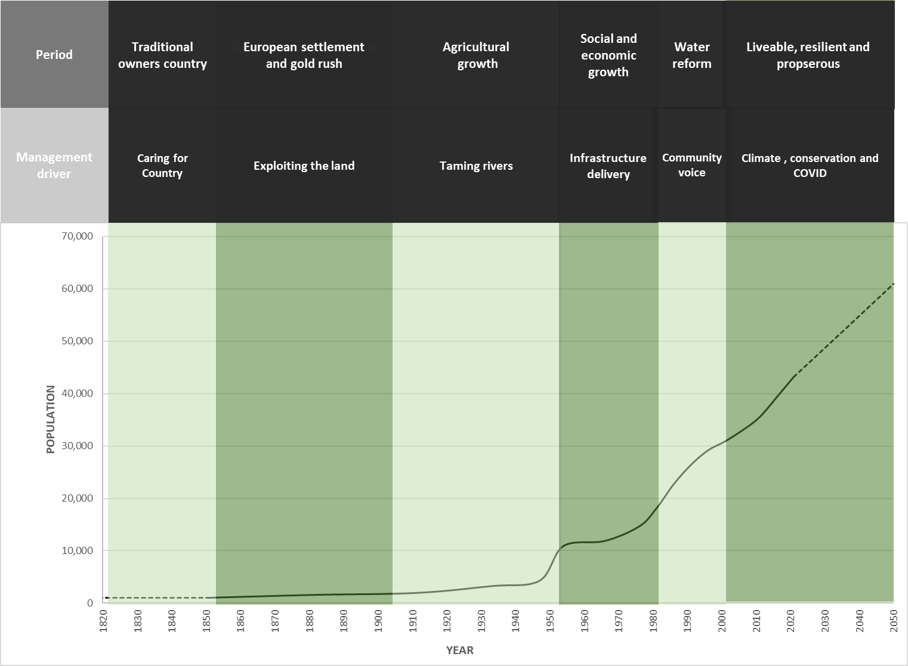

Figure 3. Key periods and drivers in Insert place name’s water story

Insert descriptions of major changes in water use and management, e.g.:

[Pre-1800]: Traditional Owners’ country

1820–1900: Settlement, exploiting the land and transforming natural landscapes

**1900–1950: Population growth**

1950–1980: Social and economic transformation

1980–2000: Reforms

The 1980s and 1990s was a period of major reform driven by state and national economic policy agendas. During this period, water servicing functions were separated from local government, and multiple water and sewerage providers were merged into new organisations such as XXXX

2000–present: Economic prosperity

Insert place name’s economy continues to evolve.

1. Looking ahead – A vision for Insert place name

No timeframe is given for the shared WSC vision for Insert place name; the intent is to think long term. This approach helps people to stretch their ambitions beyond today’s water and urban planning systems and to reflect on the potential for transformative change that is possible over such a period.

The aspirations of participants for Insert place name’s water future are expressed as a suite of outcome statements with accompanying rich descriptions.

WSC vision for Insert place name

Insert vision

Purpose

Insert purpose

Objectives

Insert objectives

Insert figure if appropriate

Figure 4. Strategic Directions Framework for Insert place name

Objective 1: XXX

Insert description

**Objective 2: XXX**

Insert description

Objective 3: XXX

Insert description

Objective 4: XXX

Insert description

Objective 5: XXX

Insert description

Objective 6: XXX

Insert description

Objective 7: XXX

Insert description

Objective 8 XXX

Insert description

1. Assessing Insert place name’s current WSC performance

Planning Insert place name’s transition to its WSC vision requires a detailed understanding of its current performance in relation to its aspirations. The Water Sensitive Cities Index[2] is a benchmarking tool designed for this purpose. It articulates 7 goals (Figure 5), which organise 34 indicators representing the major attributes of a water sensitive city (see Figure X, Appendix 1). These indicators are also mapped to the city–states in the Urban Water Transitions Framework (Figure 2) to provide a benchmarked city–state.

***Figure 5.*** 7 Goals in the Water Sensitive Cities Index

While a city’s local WSC vision may not emphasise all indicators of the WSC Index to the same degree, the tool enables diagnosis of key areas of strength and aspects for improvement. These insights can then help practitioners prioritise action and provide a framework for ongoing monitoring and evaluation of a city’s water sensitive performance.

4.1 Insert place name’s benchmark scores

Figure 6 presents the benchmark results for Insert place name (shown by the shaded area). Table 2 (in Appendix 2) provides the individual scores for each indicator.

***Figure 6. Goal area*** results for Insert place name

4.2 Insert place name’s benchmarked city–state

Figure 7 summarises the city–state benchmarking results for Insert place name. This section summarises the key elements that contributed to the overall percentage attainment of each city–state.

Insert summary of city–states results

* XXX% Water Supply City – Short description of factors explaining this result.
* XXX% Sewered City – Short description of factors explaining this result.
* XXX% Drained City – Short description of factors explaining this result..
* XXX% Waterway City – Short description of factors explaining this result.
* XXX% Water Cycle City – Short description of factors explaining this result.
* XXX% Water Sensitive City – Short description of factors explaining this result.

Figure 7. City–state results for Insert place name

1. Advancing the WSC transition

Insert place name’s benchmark scores reflect the prevailing structures, cultures and practices of urban and water system planning, design, management, engagement and decision making. It follows that a transition towards the WSC vision will necessarily require changes across each aspect.

These changes are likely to happen over a long timeframe, in the order of decades, as new WSC practices become established and replace old practices. Research shows these WSC transitions unfold over 6 phases:   
(1) Problems begin to emerge with existing servicing models and practices (e.g. declining water security, waterway health or liveability) and (2) the key issues become more clearly defined; (3) more and more people develop a shared understanding and agreement about the issue, the need to act becomes more urgent and then (4) solutions to the issue are put forward and trialled and tested and; in time preferred and feasible new solutions are (5) formalised in policy and practice, eventually becoming (6) embedded as the new mainstream practice (Figure 8). Appendix 1 provides additional information on WSC transitions.

***Figure 8. The phases of transition***

Significant research on sustainability transitions was applied in 6 Australian cities and towns to create a ‘Transitions Framework’ that can be used to plan and guide these transitions. The Water Transition Framework[3] sets out 6 enabling factors that help to overcome barriers to WSC practice and drive progress through these phases of change: champions, platforms for connecting, science and knowledge, projects and applications, and technical and administrative tools.

Building the momentum for a transition requires a diverse range of strategic actions that progressively establish these enabling conditions. Actions with the most impact during the early phases of transition will be different from those during the later phases. It is important to identify these early phase actions according to how effective they will be in accelerating the WSC transition.

This section presents recommended strategic actions for Insert place name’s WSC transition, based on analysis of transition progress to date, and insights from other cities that have developed WSC transition strategies.

How to interpret a transition assessment

A transition assessment looks at barriers and enablers to a WSC vision using the Transition Dynamics Framework. This assessment focuses on the practices needed to support a WSC vision (such as options evaluation or leadership), not on WSC outcomes (such as water quality improvements). From this, a series of strategies can be developed to advance the transition to WSC practice as a mainstream practice.

There are 3 main steps in the process:

1. Use the benchmarking results, and discussion with stakeholders, to identify the underlying causes of the results: what is working well and what barriers are practitioners encountering? Select a practice change to focus on. In this project, the process was repeated for each Index Goal Area.
2. Assess each enabling factor, as it relates the desired practice change/Goal Area. This is done using a rubric to identify how progressed each enabling factor is, through 7 phases. The green ratings (i.e. the progress level that is ‘fully present’) determines the current phase of practice change.

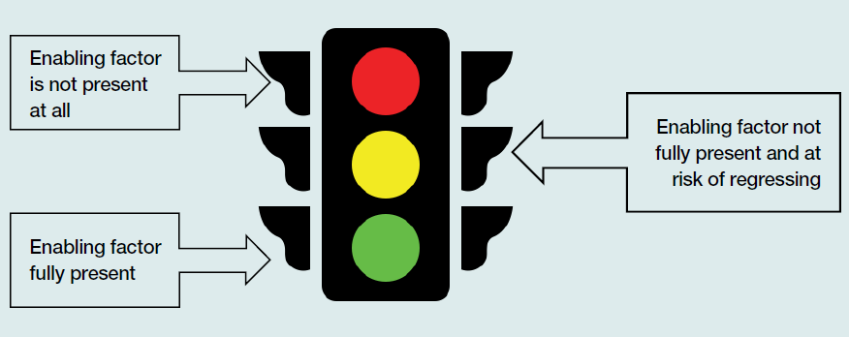

1. The aim is to move to the next phase. This can be achieved by targeting the yellow (not fully present) phases and developing actions that convert them into a green (fully present) rating. This approach is backed by transition theory that demonstrates this is how system change unfolds over time.

5.1 Assessing Insert place name’s transition progress

The assessment process involved workshops to assess the transition progress and enabling conditions for each Goal Area of the 7 WSC Index goals. The results from the workshop discussions and assessment were plotted in a traffic light matrix (Figure 9) that highlights where to focus effort to accelerate and embed transformative change. Individual matrices for each Goal Area can be found in Appendix 3.

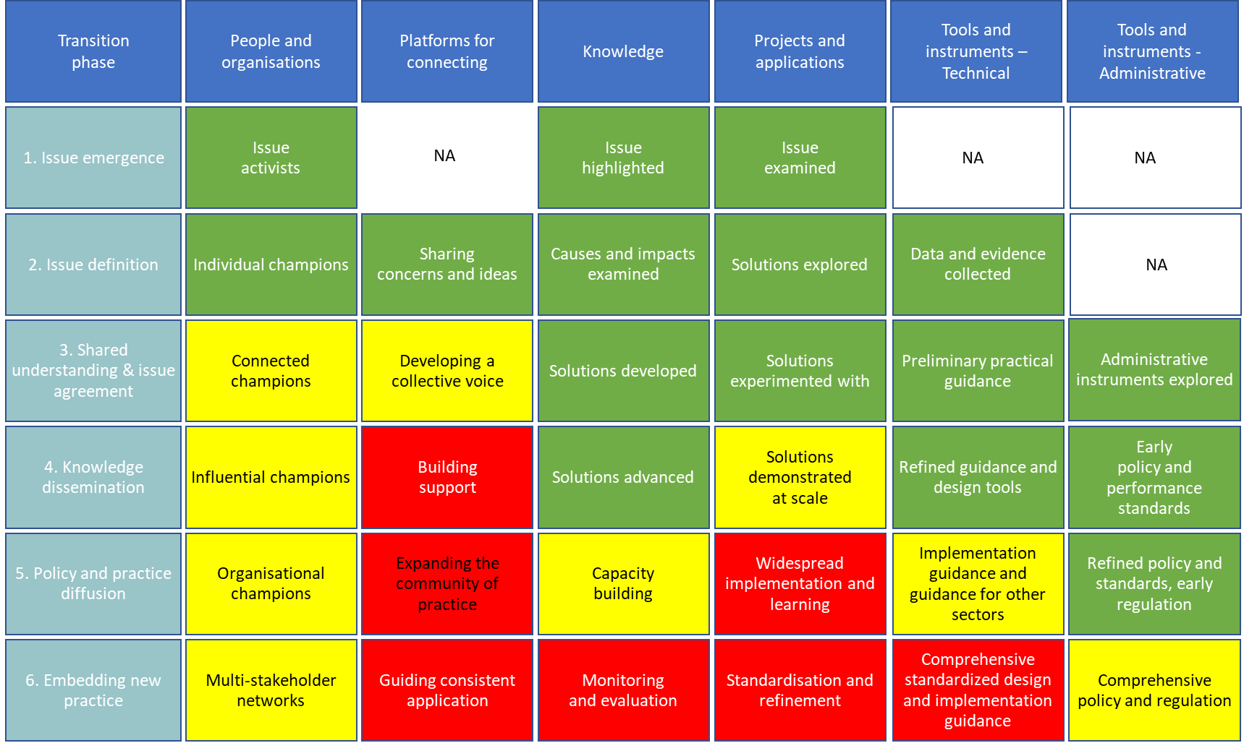

***Figure 9. Water transitions framework representing Insert place name’s WSC transition phases and the status of enabling conditions***

Note: Green= embedded, yellow= in progress, red= not yet in progress.

This transition assessment highlights the foundation for Insert place name’s WSC transition, as well as where the opportunity lies to accelerate and embed WSC practices:

* **Overall** – XXX
* **Champions** – XXX
* **Knowledge** – XXX
* **Projects and applications** – XXX
* **Technical tools and instruments** – XXX
* **Administrative tools and instruments** – XXX

However, implementation challenges remain. WSC principles and practices are yet to be fully embraced and operationalised by key organisations. Continued progress towards the WSC vision is at risk of stagnation if critical enabling conditions are not established.

The enabling conditions are weak in the domains of XXX. Insert description of focus areas.

5.2 XX strategies to embed WSC practice

A series of transition strategies have been developed as a framework to guide Insert place name towards its WSC aspirations (Table 1). The strategies are derived from the benchmarking and transition analysis but are categorised as:

1. Strategies to influence the inputs for WSC. These XX strategies address gaps in WSC practices and will improve the transition analysis results.
2. Strategies to influence the outputs of WSC. These XX strategies help to improve the benchmarking results.

Together, these strategies will guide and accelerate Insert place name’s WSC transition.

**Table 1. Summary of strategies**

|  |  |
| --- | --- |
| **Input strategies: where to lift WSC as a practice** | **Output strategies: what to focus on to lift WSC benchmarks** |
| 1. XXX 2. XXX 3. XXX 4. XXX 5. XXX | 1. XXX 2. XXX 3. XXX 4. XXX 5. XXX |

Strategy 1. XXX

Insert description

*Example action:*

* *XXX*
* *XXX*

Strategy 2. XXX

Insert description

*Example action:*

* *XXX*
* *XXX*

Strategy 3. XXX

Insert description

*Example action:*

* *XXX*
* *XXX*

Strategy 4. XXX

Insert description

*Example action:*

* *XXX*
* *XXX*

Strategy 5. XXX

Insert description

*Example action:*

* *XXX*
* *XXX*

Strategy 6. XXX

Insert description

*Example action:*

* *XXX*
* *XXX*

Strategy 7. XXX

Insert description

*Example action:*

* *XXX*
* *XXX*

Strategy 8. XXX

Insert description

*Example action:*

* *XXX*
* *XXX*

Strategy 9. XXX

Insert description

*Example action:*

* *XXX*
* *XXX*

Strategy 10. XXX

Insert description

*Example action:*

* *XXX*
* *XXX*

1. Towards strategy implementation

Transitioning towards a WSC vision involves multiple institutions and individuals acting with common purpose.

Progressing implementation of the strategies identified in this report requires further work that goes beyond the scope of this current project. Specific considerations may include:

1. developing a long list of possible actions to drive the recommended enabling strategies, whether as part of urban planning or to support this
2. prioritising outcomes to address in the short to medium term, potentially drawing on the Water Sensitive Cities Index results
3. prioritising actions based on factors such as target outcome, feasibility, benefit and potential leverage of current or upcoming projects, initiatives or available resources
4. conducting action planning for prioritised actions to determine targets, timeframes, budgets, roles and responsibilities
5. developing business cases to progress particular actions or initiatives
6. developing a structure and process to maintain collective momentum across the organisations and individuals who are committed to implementing the strategy
7. developing strategic communications and influencing to secure organisational support and endorsement for implementing the strategy
8. developing a framework for ongoing monitoring and evaluation of transition actions.

Ultimately, this transition strategy is intended as a resource for Insert key organisations to guide future action to achieve their WSC vision. Water Sensitive Cities Australia has been supporting other cities to implement their transition strategies and can offer guidance to Insert key organisations by providing tools, strategic advice, facilitation of further processes, and sharing of lessons from other places.

1. Conclusion

Insert summary

1. References

Brown, R.R., Keath, N., & Wong, T. (2009). Urban water management in cities: Historical, current and future regimes. *Water Science and Technology*, 59(5), 847-55.

CRCWSC (2018). *Water Sensitive Cities Index*. Retrieved from https://watersensitivecities.org.au/solutions/wsc-index/

Appendix 1. Urban Water Transitions Framework

*The following is adapted from Brown et al. (2016) and WSCA (2022).*

Introduction

The water systems in many cities and towns are challenged by climate change and rapid urbanisation. In response, many practitioners and decision makers are now recognising that solutions lie in promoting water’s role in supporting urban liveability, sustainability and resilience for a region’s long-term prosperity.

In Australia, IWM is now widely used to represent this concept. IWM promotes water security, effective sewerage, healthy ecosystems, cool green landscapes, minimal disruptions from flooding, efficient use of resources, and beautiful urban spaces that feature water and bring the community together. On-ground implementation of IWM involves innovative infrastructure, design and governance solutions, often with a focus on generating multiple benefits. For example, water sensitive urban designs integrate green infrastructure into the landscape to provide stormwater treatment, as well as amenity benefits and mitigation of urban heat island effects, and potentially stormwater harvesting to provide a new water source.

It can be immediately seen that this is a departure from the conventional mode of water servicing in urban areas, which manages water as separate streams for water supply, wastewater and stormwater. While these traditional water systems have given us critical benefits, such as water security, we now recognise that adaptations are needed to address emerging vulnerabilities that result from these conventional approaches, such as degraded waterways, exposure to uncertain and extreme rainfall patterns, and growing community expectations for improved liveability.

Navigating this transition from conventional modes of water services towards IWM can be challenging. Research to better understand how water sector stakeholders can deliberately address this challenge led to the development of the Water Sensitive Transition Tools – a toolbox that helps stakeholders understand, articulate and operationalise their journey towards IWM. The transition tools comprise several elements.

The Urban Water Transitions Framework

The Urban Water Transitions Framework (Brown et al, 2009) helps cities understand their journey towards IWM (referred to as a Water Sensitive City in the framework). The framework identifies 6 developmental states that cities move through on their path towards increased water sensitivity. Figure 10 presents the Urban Water Transitions Framework.

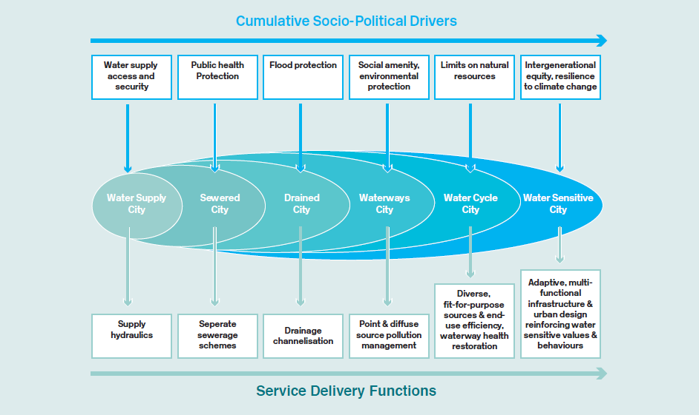

***Figure 10. The Urban Water Transition Framework (Brown et al, 2009)***

The first 3 states of water management meet largely utilitarian expectations of supplying water, protecting public health and mitigating the impacts of floods. The following 3 states mark a significant shift beyond survival needs, towards a more sophisticated goal of greater water self-sufficiency and reduced environmental impact. Importantly, the framework reflects an embedded continuum, whereby later city–states build on infrastructure and approaches achieved in earlier city–states.

Most cities in the world would appear somewhere on this continuum, but a city’s journey is not linear. Australian cities are typically somewhere between a Drained City and a Water Cycle City, and there are opportunities to share lessons between cities on what has worked in the process of implementing IWM.

The Water Sensitive Cities Index

The Water Sensitive Cities Index is a benchmarking tool for mapping a city’s location on the Urban Water Transition Framework. It uses 34 indicators that relate to 7 goals of a water sensitive city (Figure 11). Each indicator is scored on a 1–5 rating scale in a collaborative workshop process.

The Index allows benchmarking of current performance, mapping of desired future performance and identification of key areas for improvement across the 7 goal areas.

***Figure 11.*** 7 Goals And 34 Indicators of a Water Sensitive City

**The Transitions Dynamics Framework**

It is likely that some areas for improvement identified by the WSC Index will require significant changes in the way policy makers, water planners and urban planners approach their roles. Cumulatively, this can be thought of as a system change. Research shows that system changes in urban water management unfold over time in an S-curve pattern. Further, this S curve has 6 distinct phases: issue emergence, issue definition, shared understanding and issue agreement, knowledge dissemination, policy and practice diffusion, and embedding new practice. By understanding which phase a city is in, specific actions can be developed to move to the next phase.

The Transition Dynamics Framework (Brown et al., 2018) helps to make sense of these transition phases and to craft actions. Importantly, these actions are based around 6 enabling factors (Table 2) that (research also shows) must be present and effective to lock in the current phase and then move to the next phase.

Table 2. Enabling factors

|  |  |
| --- | --- |
| Champions | Key networks of individuals and organisations. Early issue activists working on specific change-related projects – reflecting their expertise – within their own organisations. Later on, these individuals can expand their networks and enrol other actors, such as senior executives, local politicians or formal government leaders to increase their influence. In the later stages of transition, organisations themselves may become champions, leading sector-wide change. |
| Platforms for connecting | (Semi) Formalised organisations, structures and processes for coordination and alignment. In the early phase, may include shadow and informal networks, which have bridging, connecting and coordinating functions across science, policy and industry. Typically, these platforms are not yet established in the issue emergence phase and will become more formalised as the transition advances. |
| Knowledge | Research, science and contextualised knowledge. This refers to both fundamental science and more applied, field-based and practical knowledge that goes beyond the laboratory and is gained through experience. In the early phase, scientific investigations help uncover root causes or impacts of particular issues. Through partnerships across science, policy and industry, knowledge gets translated to inform practical problem solving, scalability of solutions, capacity building, and monitoring and evaluation |
| Projects and applications | Experiments, demonstrations and focus projects. They are closely linked with knowledge translation, whereby scientific prototypes, proofs-of-concept, demonstration projects or other larger-scale experiments allow practitioners and industry partners to gather evidence and build capacity and experience. As transition stabilises, these projects will become more common and standardised. |
| Technical implementation guidance | Tools and guidance for solution design and implementation. This includes evidence-based practical guidelines and tools that support solution design and implementation. Early in the transition, guidance is likely to be more generic in nature (e.g. project reports, design templates). Later, guidance for tailoring solutions has developed, as well as tools to support standardisation of practice. |
| Administrative implementation guidance | Administrative instruments including policy, planning and regulation. This may start with informal exploration in a particular local jurisdiction, evolving into a range of administrative measures such as subsidies, offset schemes, commercial incentives and regulatory exemptions. Instruments will become more and more refined and standardised because of ongoing experiments, research and consensus building activities. |

When used this way, the Transition Dynamics Framework provides a checklist of the factors that should be deliberately and sequentially built up. This helps stakeholders avoid a narrow focus on individual enablers or stand alone on-ground projects. For instance, before embarking on a transitions analysis with city stakeholders, we typically observe calls to fund new demonstration projects or to introduce new regulations to support IWM without first establishing the organisational commitment, knowledge base, learning environment or implementation guidance necessary for these actions to have the intended impact.

**Transition Strategy**

A transition strategy is the culmination of the process. It documents the case for system change and outlines the priorities and actions related to the roles, process, barriers and enablers of IWM. It is different from a focus on IWM outcomes (such as the 7 IWM outcomes in the IWM Frameworks for Victoria) or place-based, on-ground actions (such as Catchment Scale IWM Plans). It can be seen that these 3 activities are mutually reinforcing, but each is insufficient on its own to successfully embed IWM.

References

Brown, R.R., Keath, N., & Wong, T.H.F. (2009). Urban water management in cities: Historical, current and future regimes. *Water, Science and Technology*, A Journal of the International Association on Water Pollution Research, 59(5), 847–55.

Brown, R., Rogers, B., Werbeloff, L. (2016). *Moving toward Water Sensitive Cities: A guidance manual for strategists and policy makers.* Melbourne, Australia: Cooperative Research Centre for Water Sensitive Cities.

Brown, R.R., Rogers, B.C., Werbeloff, L. (2017). A framework to guide transitions to water sensitive cities. Chapter 9 in Moore, T., de Haan, F.J., Horne, R. & Gleeson, B. (Eds) *Urban Sustainability Transitions: Australian Cases – International Perspectives.* Springer, Japan.

Water Sensitive Cities Australia. (2022). *WSC Transition Tools Manual Version 1.* Melbourne, Australia: Water Sensitive Cities Australia.

Wong, T.H.F., & Brown, R.R. (2009). The Water Sensitive City: Principles for practice. *Water, Science and Technology,* A Journal of the International Association on Water Pollution Research, 60(3), 673–82.

Appendix 2 Benchmark results

**Table 3. Water Sensitive Cities index scores (goals and indicators) for Insert place name**

|  |  |  |  |
| --- | --- | --- | --- |
| **Indicator** | **Score** | **Indicator** | **Score** |
| **1. Ensure good water sensitive governance** |  | **4. Improve productivity and resource efficiency** |  |
| 1.1. Knowledge, skills and organisational capacity |  | 4.1. Benefits across other sectors because of water-related services |  |
| 1.2. Water is key element in city planning and design |  | 4.2. Low GHG emission in water sector |  |
| 1.3. Cross-sector institutional arrangements and processes |  | 4.3. Low end-user potable water demand |  |
| 1.4. Public engagement, participation and transparency |  | 4.4. Water-related business opportunities |  |
| 1.5. Leadership, long-term vision and commitment |  | 4.5. Maximised resource recovery |  |
| 1.6. Water resourcing and funding to deliver broad societal value |  | 5. **Improve ecological health** |  |
| 1.7. Equitable representation of perspectives |  | 5.1. Healthy and biodiverse habitat |  |
| 2. **Increase community capital** |  | 5.2. Surface water quality and flows |  |
| 2.1. Water literacy |  | 5.3. Groundwater quality and replenishment |  |
| 2.2. Connection with water |  | 5.4. Protect existing areas of high ecological value |  |
| 2.3. Shared ownership, management and responsibility of water assets |  | 6. **Ensure quality urban space** |  |
| 2.4. Community preparedness and response to extreme events |  | 6.1. Activating connected pleasant urban green and blue space |  |
| 2.5. Indigenous involvement in water planning |  | 6.2. Urban elements functioning as part of the urban water system |  |
| 3. **Achieve equity of essential services** |  | 6.3. Vegetation coverage |  |
| 3.1. Equitable access to safe and secure water supply |  | 7. **Promote adaptive infrastructure** |  |
| 3.2. Equitable access to safe and reliable sanitation |  | 7.1. Diversify self-sufficient fit-for-purpose water supply |  |
| 3.3. Equitable access to flood protection |  | 7.2. Multi-functional water infrastructure system |  |
| 3.4. Equitable and affordable access to amenity values of water-related assets |  | 7.3. Integration and intelligent control |  |
|  |  | 7.4. Robust infrastructures |  |
|  |  | 7.5. Infrastructure and ownership at multiple scales |  |
|  |  | 7.6. Adequate maintenance |  |

Appendix 3 Goal Area transition results

This appendix considers each Water Sensitive City Goal Area in turn, providing commentary on the current and desired future state, and summarising the identified strategies to embed the relevant practice change. These Goal Area strategies are informed by the Transition Dynamics Framework.

Goal Area 1 – Ensure good water sensitive governance

What this goal area includes:

* Practitioners have WSC skills and knowledge, foster meaningful engagement and enhance inter-organisational planning and delivery.
* Urban planning decisions, processes and practices support WSC outcomes[4].
* Institutional processes support robust, effective, transparent and stable cross-sectoral arrangements, with joint accountability between all sectors, organisations and levels on how WSC goals should be achieved.
* Citizens are meaningfully involved and empowered in decision making processes.
* The shared vision and narrative for urban water management links to broader regional aspirations and drives innovation and WSC practice across all sectors and government levels.
* Revenue, funding and investment models include non-market values and drive investments.
* Many different perspectives are included in urban water governance arrangements and decision making.

Scoring

|  |  |
| --- | --- |
| How does place rate today? | How does place want to rate in the future? |
| XX/5 | XX/5 |

Main areas for improvement in benchmarking score (followed by the current benchmark score)

* XXX (XX/5)
* XXX (XX/5)
* XXX (XX/5)

Required practice change

* XXX
* XXX

Transitions analysis (what is the status of this new practice?)

* XXX
* XXX
* XXX
* XXX

Figures XX and XX outline the transition analysis for this goal area, and strategies recommended to advance to the next phase of change.

*Figure XX. Assessment of presence of enabling factors to support the new practice*

***Figure XX. Strategic actions to advance to the next transition phase***

|  |  |
| --- | --- |
| Goal Area strategies | Outcomes |
| 1. XXX 2. XXX 3. XXX 4. XXX | * XXX * XXX * XXX * XXX |

Goal area 2 – Increase community capital

What this goal area includes:

* Traditional Owners’ economic, cultural and spiritual interests are actively considered in the planning and management of water systems
* Citizens have good knowledge of the water cycle, the water sector and the current state of water affairs to actively participate in decision making.
* People have pride and connectedness with water through their understanding of water's role in landscape.
* Community members are active participants in creating, operating and maintaining the water system and its infrastructures.
* Citizens have the capacity to cope with extreme water-related events.

Scoring

|  |  |
| --- | --- |
| How does place rate today? | How does place want to rate in the future? |
| XX/5 | XX/5 |

Main areas for improvement in benchmarking score (followed by the current benchmark score)

* XXX (XX/5)
* XXX (XX/5)
* XXX (XX/5)

Required practice change

* XXX
* XXX

Transitions analysis (what is the status of this new practice?)

* XXX
* XXX
* XXX
* XXX

Figures XX and XX outline the transition analysis for this goal area, and strategies recommended to advance to the next phase of change.

*Figure XX. Assessment of presence of enabling factors to support the new practice*

***Figure XX. Strategic actions to advance to the next transition phase***

|  |  |
| --- | --- |
| Goal Area strategies | Outcomes |
| * 1. XXX   2. XXX   3. XXX   4. XXX | * XXX * XXX * XXX * XXX |

Goal area 3 – Achieve equity of essential services

What this goal area includes:

* Provide safe, secure and affordable water supply services that are accessible to all households, educational institutions, health institutions and businesses.
* Provide reliable sanitation services that is affordable and accessible to all households, educational institutions, health institutions and businesses.
* Reduce nuisance flooding to protect citizens and infrastructure and to deliver affordable protection against flood risk to everyone.
* Enhance amenity values associated with urban landscapes and provide affordable access to water related assets with high amenity values to everyone.

Scoring

|  |  |
| --- | --- |
| How does place rate today? | How does place want to rate in the future? |
| XX/5 | XX/5 |

Main areas for improvement in benchmarking score (followed by the current benchmark score)

* XXX (XX/5)
* XXX (XX/5)
* XXX (XX/5)

Required practice change

* XXX
* XXX

Transitions analysis (what is the status of this new practice?)

* XXX
* XXX
* XXX
* XXX

Figures XX and XX outline the transition analysis for this goal area, and strategies recommended to advance to the next phase of change.

*Figure XX. Assessment of presence of enabling factors to support the new practice*

***Figure XX. Strategic actions to advance to the next transition phase***

|  |  |
| --- | --- |
| Goal Area strategies | Outcomes |
| * 1. XXX   2. XXX   3. XXX   4. XXX | * XXX * XXX * XXX * XXX |

Goal area 4 – Improve productivity and resource efficiency

What this goal area includes:

* Stimulate beneficial outcomes for the public beyond those attained through water-related essential services.
* Reduce the levels of GHG emissions and maximise the use of alternatives to high carbon emitting energy sources to supply water infrastructure.
* Support the valuing of water as a scarce resource.
* Stimulate investment in new business opportunities through innovation in the water sector.
* Maximise resource recovery through innovative water system design

Scoring

|  |  |
| --- | --- |
| How does place rate today? | How does place want to rate in the future? |
| XX/5 | XX/5 |

Main areas for improvement in benchmarking score (followed by the current benchmark score)

* XXX (XX/5)
* XXX (XX/5)
* XXX (XX/5)

Required practice change

* XXX
* XXX

Transitions analysis (what is the status of this new practice?)

* XXX
* XXX
* XXX
* XXX

Figures XX and XX outline the transition analysis for this goal area, and strategies recommended to advance to the next phase of change.

*Figure XX. Assessment of presence of enabling factors to support the new practice*

***Figure XX. Strategic actions to advance to the next transition phase***

|  |  |
| --- | --- |
| Goal Area strategies | Outcomes |
| * 1. XXX   2. XXX   3. XXX   4. XXX | * XXX * XXX * XXX * XXX |

Goal area 5 – Improve ecological health

What this goal area includes:

* Ensure water system services help to protect, restore and create well-functioning ecosystems that contribute to ecological resilience.
* Improve and protect the quality of surface waters and marine environments.
* Improve and protect the quality of groundwater-connected environments.
* Protect existing areas of high ecological value from the impacts of catchment urbanisation.

Scoring

|  |  |
| --- | --- |
| How does place rate today? | How does place want to rate in the future? |
| XX/5 | XX/5 |

Main areas for improvement in benchmarking score (followed by the current benchmark score)

* XXX (XX/5)
* XXX (XX/5)
* XXX (XX/5)

Required practice change

* XXX
* XXX

Transitions analysis (what is the status of this new practice?)

* XXX
* XXX
* XXX
* XXX

Figures XX and XX outline the transition analysis for this goal area, and strategies recommended to advance to the next phase of change.

*Figure XX. Assessment of presence of enabling factors to support the new practice*

***Figure XX. Strategic actions to advance to the next transition phase***

|  |  |
| --- | --- |
| Goal Area strategies | Outcomes |
| * 1. XXX   2. XXX   3. XXX   4. XXX | * XXX * XXX * XXX * XXX |

Goal area 6– Quality open space

What this goal area includes:

* Ensure the presence of many, distributed and well-connected green spaces and water assets.
* Ensure adequate urban space and built form functions as an integral part of the water system.
* Ensure adequate vegetation coverage (e.g. tree canopies).

Scoring

|  |  |
| --- | --- |
| How does place rate today? | How does place want to rate in the future? |
| XX/5 | XX/5 |

Main areas for improvement in benchmarking score (followed by the current benchmark score)

* XXX (XX/5)
* XXX (XX/5)
* XXX (XX/5)

Required practice change

* XXX
* XXX

Transitions analysis (what is the status of this new practice?)

* XXX
* XXX
* XXX
* XXX

Figures XX and XX outline the transition analysis for this goal area, and strategies recommended to advance to the next phase of change.

*Figure XX. Assessment of presence of enabling factors to support the new practice*

***Figure XX. Strategic actions to advance to the next transition phase***

|  |  |
| --- | --- |
| Goal Area strategies | Outcomes |
| * 1. XXX   2. XXX   3. XXX   4. XXX | * XXX * XXX * XXX * XXX |

Goal area 7 – Promote adaptive infrastructure

What this goal area includes:

* Meet end users’ quality water and demand requirements with flexible and adaptive water supply systems.
* Seamlessly integrate multi-functional water infrastructure into the urban landscape.
* Optimise water system network performance using a smart city approach.
* Create a water system network that is virtually insensitive to stresses through the use of redundancy measures and by-pass systems
* Optimise water system performance by combining centralised and decentralised infrastructure.
* Apply appropriate maintenance practice and policies to ensure the long-term integrity, operation and maintenance of water infrastructure (including green infrastructure).

Scoring

|  |  |
| --- | --- |
| How does place rate today? | How does place want to rate in the future? |
| XX/5 | XX/5 |

Main areas for improvement in benchmarking score (followed by the current benchmark score)

* XXX (XX/5)
* XXX (XX/5)
* XXX (XX/5)

Required practice change

* XXX
* XXX

Transitions analysis (what is the status of this new practice?)

* XXX
* XXX
* XXX
* XXX

Figures XX and XX outline the transition analysis for this goal area, and strategies recommended to advance to the next phase of change.

*Figure XX. Assessment of presence of enabling factors to support the new practice*

***Figure XX. Strategic actions to advance to the next transition phase***

|  |  |
| --- | --- |
| Goal Area strategies | Outcomes |
| * 1. XXX   2. XXX   3. XXX   4. XXX | * XXX * XXX * XXX * XXX |



1. Brown, R., Keath, N., & Wong, T. (2009). Urban water management in cities: historical, current and future regimes. Water Science and Technology: A Journal of the International Association on Water Pollution Research, 59(5), 847–55.
2. See CRC for Water Sensitive Cities (2021). Water Sensitive Cities Index. Retrieved from: <https://watersensitivecities.org.au/water-sensitive-cities-index-tool/>
3. See CRC for Water Sensitive Cities (2021). Transition Dynamics Framework. Retrieved from: <https://watersensitivecities.org.au/transition-dynamics-framework-tool/>
4. WSC outcomes are defined in terms of social values: liveable, resilience, regional prosperity, healthy environments.